Powerful metrology software

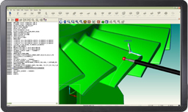

Renishaw's metrology software provides a powerful platform for 5-axis measurement. A configurable user interface allows native DMIS programs to be developed offline, drawing geometry, embedded dimensions and tolerance data from CAD, with full simulation and collision detection. The software includes certified algorithms for feature measurement, feature construction and part alignment.

Programs can be created offline directly from CAD with on-screen probe path verification. The CMM environment, the fixture and the location of the part on the machine can all be defined, enabling full simulation and crash detection of 5‑axis measurement programs. This minimises CMM down-time as programs arrive at the machine ready to run, with little or no prove-out time required.

The MODUS metrology software suite is a future-proof investment, ensuring guaranteed availability of the latest sensor and controller technology advancements from Renishaw. This will include future sensors for the 5-axis measurement product range, which represents the biggest step-change in measurement capability ever introduced and delivers unprecedented speed and measurement flexibility, whilst avoiding the speed versus accuracy compromises inherent in conventional techniques.

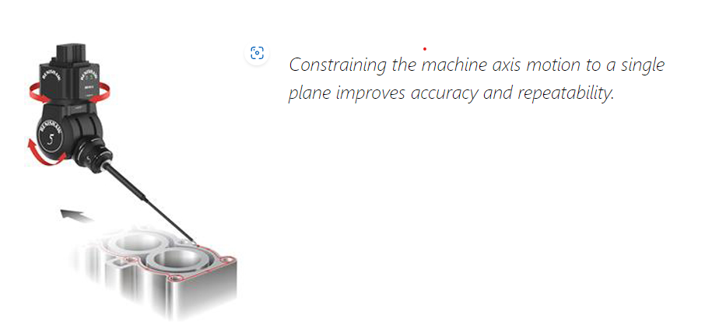

### **Why constrain the CMM motion?**

Constraining one or more axis of the CMM maximises the use of REVO® head motion and minimises the motion of the CMM. By constraining two axes and moving only in the one axis parallel to the plane being measured, machine bending is in the plane that's being inspected and as such no error is seen. This presents the opportunity to measure parts quicker or achieve a higher level of accuracy from an existing machine.

For example, when measuring the flatness of a cylinder block sealing face, constraining two axes enables the machine to be operated faster without introducing measurement errors. Ideally, the Z-axis of the machine is used to move the REVO up and down as it has the lowest moving mass and X and Y are constrained. In this case, there are no bending forces, just compression/tension along the length of the quill where it is very stiff. If Z isn't possible, then X (constrained in Z and Y) is the next best as it has the next lowest moving mass. Using Y will still benefit from this method compared to moving the head towards and away from the part as done with traditional 5-axis scans.

# **MODUS™ Planning Suite**

The new MODUS Planning Suite makes complex part programming easy.

### **Master your CMM with minimal effort and improved efficiency with MODUS Planning Suite.**

The MODUS Planning Suite is designed to provide MODUS users with a set of automated shortcuts to solve frequent challenges in part programming, maximising the efficiency of their REVO® CMM head with easy-to-use specialised software applications. The MODUS Planning Suite applications allow users to plan measurement paths around complex geometry components with minimal effort and improved efficiency.

Harnessing advanced planning technology, the software provides offline tools with simulated motion to create DMIS code representing collision‑free part measurement.

There are currently three modular applications separately available for the MODUS Planning Suite platform:

* [MODUS Blade planner](https://www.renishaw.com/en/modus-planning-suite--45491#ElementHTML155156)
* [MODUS Patch planner](https://www.renishaw.com/en/modus-planning-suite--45491#ElementHTML151336)
* [MODUS Curve planner](https://www.renishaw.com/en/modus-planning-suite--45491#ElementHTML151338)

## Find effective shortcuts to complex part programming with MODUS Planning Suite

### **MODUS Blade planner**

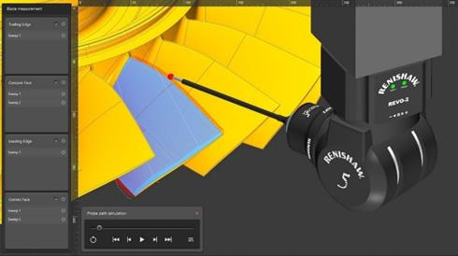

**Blade measurement**

The full blade inspection option in MODUS Blade planner enables the user to plan sweep scans on concave, convex, leading and trailing edge surfaces.

The settings and measurement strategies allow the user to customise the measurement paths, providing the ability to control the number of sweeps per surface and to change the direction of measurements between longitudinal and transverse sweeps.

Adaptive Edge Scan (AES) is a measurement operation on the leading or trailing edge. The measurement takes place prior to sweep scan and adapts the position and probe orientations of the edge sweep so that the sweep scan runs smoothly.

**Section measurement**

The Blade planner module offers two methods to measure blade sections:

* Sweep scans over sections with the option of joined sweeps.  
  High density sweep scans cover the sections where airfoil data is collected, whilst low density sweep scans occur between the sections where no data is collected. This method also reduces the number of approach and retract moves, hence reducing cycle time.
* Section curve scans on faces  
  Curve scans are created on the concave and convex faces, and full sweep scans are created on the leading and trailing edges.

MODUS Planning Suite generates the required DMIS to measure the airfoil surface. MODUS 1.9 can then execute this DMIS and allow the user to perform the airfoil analysis on each section.

**Patch measurement**

To provide the tools to plan the path for the complete blade and surrounding surfaces, the MODUS Blade planner module incorporates all the selection methods available in MODUS Patch planner:

* Create a patch from an outline of points (Area)
* Select a patch from selected faces (Face)
* Create a patch from points on a centreline
* Create a patch from CAD edges

See a full description of the MODUS Patch planner module for MODUS Planning Suite below.

Other modular applications separately available for the MODUS Planning Suite are:

* [MODUS Patch planner](https://www.renishaw.com/en/modus-planning-suite--45491#ElementHTML151336)
* [MODUS Curve planner](https://www.renishaw.com/en/modus-planning-suite--45491#ElementHTML151338)

### **MODUS Patch planner**

Until now, users had to define their own paths for surface sweeps using manual manipulation tools to avoid collisions. Now, the new MODUS Patch application delivers the most efficient measurement path with the REVO RSP2 sensor, quickly and easily, with automatic path planning.

* **Create patches from points**  
  Define a sweep path by creating a series of points to create a four-sided area on the CAD.
* **Create patches from a face**  
  Click on the CAD model to select a surface or set of connected surface points to define the patch.
* **Create patches from CAD edges**Use the CAD edges to determine the sweep path. A MODUS slice can also be selected as an edge using this tool. The software generates the shortest path when start and end points are selected.
* **Create patches by drawing a centre line**  
  Define a sweep path by creating a series of centre line points on a surface.

Once the selection method is established, edits to the sweep width, direction and other characteristics can be made in the settings menu, if required.

Other modular applications separately available for the MODUS Planning Suite are:

* [MODUS Blade planner](https://www.renishaw.com/en/modus-planning-suite--45491#ElementHTML155156)
* [MODUS Curve planner](https://www.renishaw.com/en/modus-planning-suite--45491#ElementHTML151338)

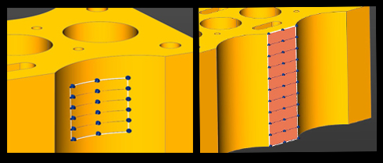

Point and face sweep generation

### ***MPS Patches from centreline and CAD edges***

CAD edge and centre line sweep generation

### **MODUS Curve planner**

The curve planning module includes two options: RSP2 Curve and RSP3 Curve. RSP3 provides increased capability to measure complex geometries using different probe assemblies.

Curves can be defined by the selection of edges from the CAD model or by clicking points on a plane.

**Create curve on CAD edges**Curves are defined by either selecting edges of the CAD model or edges of a slice created using MODUS.

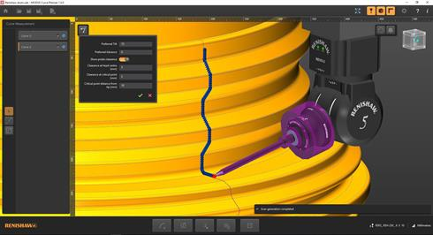

**Sketch a curve on a plane**  
Curves are defined by clicking a number of points on the plane. A spline is fitted to create the path.

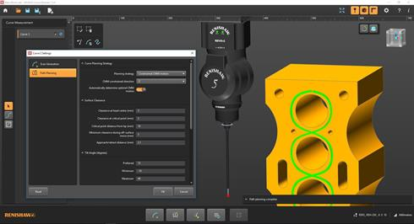

#### **Additional choices for the RSP2 Curve option**

**Create an edge offset on a plane**

Once the required plane is selected on the CAD model and the edges are chosen, an offset value will be applied.

A set of graphical options complements the software settings, making it easy to join and trim paths, which delivers the most efficient result.

Multiple edges can be selected on a single face and then joined. This creates measurement that does not leave the surface, reducing the time taken for moves between measurements.

**Create an edge offset avoiding features on a plane**

Once a plane and edge have been selected, this option automatically detects and avoids geometry in the CAD model that the measurement needs to avoid, updating the path as offset values are adjusted.

The user can select a single edge on each curve measurement.

#### **Additional choices for the RSP3 Curve option**

**Fixed head angle segments**

The RSP3 probe measures at fixed head angles and the probe may come off surface during some curve scans so that the head angle can be changed.

The RSP3 Curve element in the MODUS Curve module provides the ability to define segments of measurement where the probe will not come away from the surface. This enables the user to meet the requirements of high accuracy zones along a single curve path.

#### **Quick and easy to use**

Once the curve is selected, editing parameters such as the scan direction, can be easily done in the settings.

For both methods of defining curves the application incorporates constrained CMM motion, which reduces the CMM axis motion when measuring curves on a plane.

The combination of constrained axes with collision-free motion planning delivers a significant reduction in programming times for quick and effective curve measurement.

Other modular applications separately available for the MODUS Planning Suite are:

* [MODUS Blade planner](https://www.renishaw.com/en/modus-planning-suite--45491#ElementHTML155156)
* [MODUS Patch planner](https://www.renishaw.com/en/modus-planning-suite--45491#ElementHTML151336)

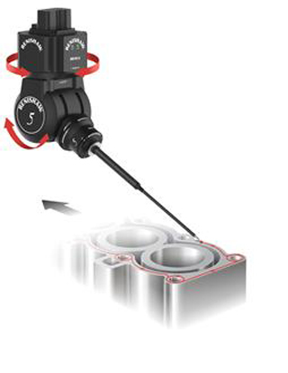

### **Constraining the machine axis motion to a single plane improves accuracy and repeatability.**

### **Why constrain the CMM motion?**

Constraining one or more axis of the CMM maximises the use of REVO® head motion and minimises the motion of the CMM. By constraining two axes and moving only in the one axis parallel to the plane being measured, machine bending is in the plane that's being inspected and as such no error is seen. This presents the opportunity to measure parts quicker or achieve a higher level of accuracy from an existing machine.

For example, when measuring the flatness of a cylinder block sealing face, constraining two axes enables the machine to be operated faster without introducing measurement errors. Ideally, the Z-axis of the machine is used to move the REVO up and down as it has the lowest moving mass and X and Y are constrained. In this case, there are no bending forces, just compression/tension along the length of the quill where it is very stiff. If Z isn't possible, then X (constrained in Z and Y) is the next best as it has the next lowest moving mass. Using Y will still benefit from this method compared to moving the head towards and away from the part as done with traditional 5-axis scans.

Combining the capability of MODUS™ Blade planner, SurfitBlade™ and MODUS™ metrology software, Renishaw's Blade Toolkit breaks through the limitations of standard measurement techniques for airfoil components.

Traditional methods determine the inspection of aerospace blades in a limited number of cross-sections. However, REVO 5-axis measurement system's sweep scanning technology enables you to accurately and quickly measure and evaluate the whole blade, collecting and analysing high-precision tactile probing data of an unlimited number of sections.

## Renishaw's Blade Toolkit

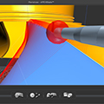

[MODUS™ Blade planner](https://www.renishaw.com/en/modus-planning-suite--45491#ElementHTML155156)

Ultra fast 5-axis sweep scan preparation and DMIS programming tool

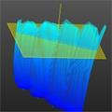

[MODUS™ point cloud sectioner](https://www.renishaw.com/en/modus-point-cloud-sectioner--16426)

For generating multiple blade sections anywhere on a blade

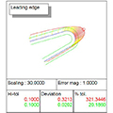

[MODUS™ airfoil analysis](https://www.renishaw.com/en/modus-airfoil-analysis--16458)

For engineering analysis of returned sections

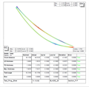

[MODUS™ reporter](https://www.renishaw.com/en/modus-reporter--16456)

For graphical reporting and statistical analysis



[SurfitBlade™](https://www.renishaw.com/en/surfitblade--16435)

For reverse engineering of the complete airfoil

### **Using the Blade Toolkit**

The first step is using MODUS Blade planner software to automatically generate a collision-free sweep scan program for the REVO 5-axis system, which is then run on the CMM using MODUS metrology software.

The sweep scan operation produces an accurate point cloud that covers the entire airfoil surface. Using MODUS point cloud sectioning functionality, it is possible to generate sections wherever required.

As the complete data set is stored, additional sections can be created at a later time without having to measure again.

The data collected can then be processed in two ways:

* **Inspection**  
  The data is sectioned by MODUS and compared to the nominal CAD model requirements. The analysis results are presented through MODUS reporter, which also produces a defined PDF document for archiving.
* **Engineering**  
  the data is processed by SurfitBlade to produce a full NURBS surface for use in aerodynamic and stress analysis.

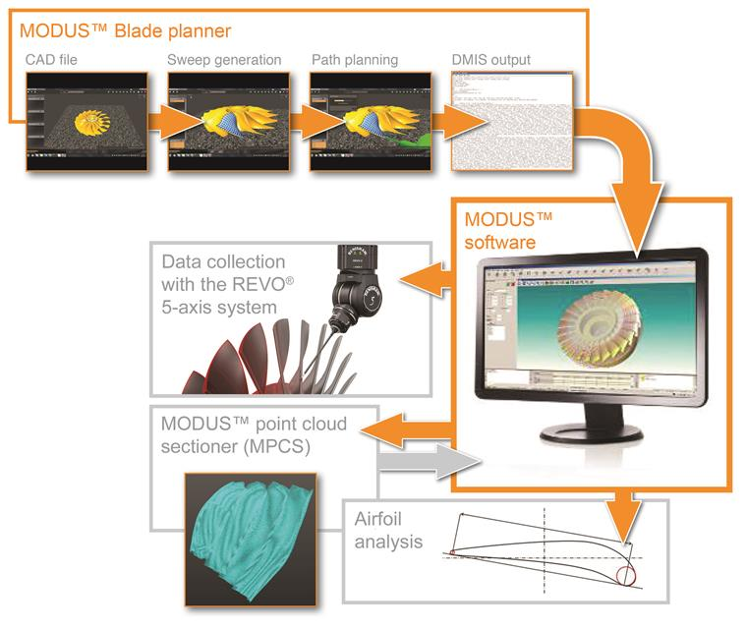

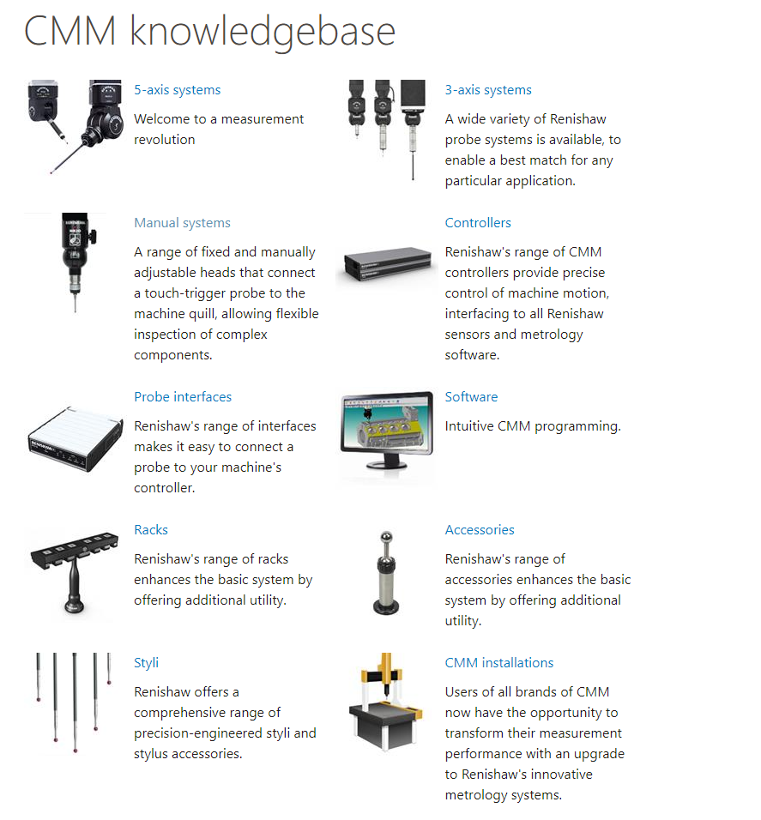

[CMM knowledgebase (renishaw.com)](https://www.renishaw.com/cmmsupport/knowledgebase/en/cmm-knowledgebase--22078)